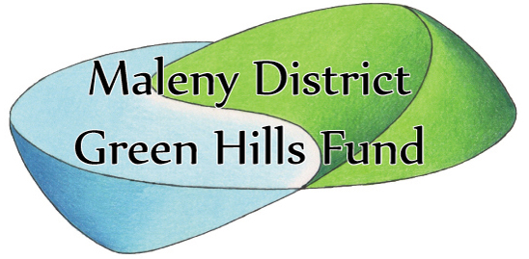
Proxy Form
ABN 86 071 444 123

I ........................................................................................................

of.......................................................................................................
being a member of the above named association hereby appoint

.........................................................................................................

of......................................................................................................

or failing him/her, ……….……………………………………………..

of.....................................................................................................
as my proxy vote for me on my behalf at the annual general meeting of the association to be held on the 14thOctober 2023, and at any adjournment thereof.
My proxy is authorized to vote * as they see fit / in favour of / against the following motions:

Signed …………………………………………this ………….day of ..................... 2022

* Strike out whichever is not desired.

Proxy forms to be received at our registered office, 455 North Maleny Rd, Maleny Qld, 4552, by 10.00am, Saturday 7th October.

